# How to Active NLPIR Platform Licenses

# （激活NLPIR平台授权手册）



[**http://ICTCLAS.nlpir.org/**](Http://hi.baidu.com/drkevinzhang/)

**@ICTCLAS张华平博士**

**2014-12**

**For the latest information about NLPIR, please visit** [**Http://ICTCLAS.nlpir.org/**](Http://ICTCLAS.nlpir.org/)

访问[http://ictclas.nlpir.org/](http://www.nlpir.org)(自然语言处理与信息检索共享平台)，您可以获取NLPIR系统的最新版本，并欢迎您关注张华平博士的新浪微博 @ICTCLAS张华平博士 交流。

Document Information

|  |  |  |  |
| --- | --- | --- | --- |
| Document ID | NLPIR-ICTCLAS-2015-LICENSE | Version | V4.0 |
| Security level | Public 公开 | Status | Creation and first draft for comment |
| Author | 张华平 | Date | Dec 19, 2015 |
| Publisher | / | Approved by |  |

Version History

Note：The first version is”v0.1”. Each subsequent version will add 0.1 to the exiting version. The version number should be updated only when there are significant changes, for example, changes made to reflect reviews. The first figure in the version 1.x denotes current review status by. 1. x denotes review process has passed round 1 etc .Anyone who create, review or modify the document should describe his action.

|  |  |  |  |
| --- | --- | --- | --- |
| Version | Author/Reviewer | Date | Description |
| V1.0 | Kevin Zhang | 2015-12-21 | first complete draft for comment. ICTCLAS2015 |
|  |  |  |  |
|  |  |  |  |
|  |  |  |  |
|  |  |  |  |
|  |  |  |  |
|  |  |  |  |
|  |  |  |  |
|  |  |  |  |
|  |  |  |  |

# 目录

How to Active NLPIR Platform Licenses 1

（激活NLPIR平台授权手册） 1

目录 4

Step 1. Find the proper license file （定位正确的授权文件） 4

Step 2. Find the proper license program according to the OS（根据操作系统版本，找到正确的授权程序） 5

Step 3a. Register License File in Linux,Skip to Step 3b if Win OS (Linux下注册授权文件；如果是Win操作系统，跳转到Step 3b) 5

Step 3b. Register License File in Windows ,Skip to Step 3a if Linux OS (Windows下注册授权文件；如果是Linux操作系统，跳转到Step 3a) 6

Step 4. Replace the system license file with the license file returned from the service agent. （将从经销商手中获取的授权授权文件替换到系统指定的文件夹中） 7

FAQ 7

Q1: Why the licensed file cannot work? (为什么授权文件不起作用) 7

Contacts 8

# 

Steps as follows:

## Step 1. Find the proper license file （定位正确的授权文件）

Two ways to find the license file. (两种方式找到对应的授权文件)

1) Download URL: https://github.com/NLPIR-team/NLPIR/tree/master/License

2) You can also get the .user file under system Data folder. (也可以从系统的数据文件夹中的.user文件)

|  |  |  |
| --- | --- | --- |
| **License File** | **Module Name (Chinese)** | **Module Name (English)** |
| DocExtractor.user | DocExtractor文档提取授权 | DocExtractor: document entity extractor |
| LJHtmlParser.user | HtmlParser网页正文提取授权 | HtmlParser: Html parser and text extractor |
| JZSearch.user | JZSearch精准搜索引擎授权 | JZSearch: JZSearch Search Engine |
| KeyExtract.user | KeyExtract关键词提取授权 | KeyExtract: Keyword Extractor |
| NLPIR.user | NLPIR-ICTCLAS分词系统授权 | NLPIR-ICTCLAS: Lexical Analysis System |
| LJRedupRemover.user | RedupRemover去重授权 | RedupRemover: Reduplicate Remover |
| Sentiment.user | Sentiment情感分析授权 | Sentiment: Sentiment Analysis System |
| Summary.user | Summary自动摘要提取授权 | Summary: Automatic Summarization System |
| deepclassifier.user | classifier深度学习分类授权 | classifier: Classifier with Deep Learning |
| classifier.user | classifier规则分类授权 | classifier: Classifier with Rules |
| cluster.user | cluster聚类授权 | cluster: Clustering |

## Step 2. Find the proper license program according to the OS（根据操作系统版本，找到正确的授权程序）

download URL: https://github.com/NLPIR-team/NLPIR/tree/master/LicenseClient

| How to Active NLPIR Platform Licenses.docx : License Program Manual

|

+---linux32bit : folder for License Program in Linux 32bit

| license : License Program

| NLPIR.user: Sample License File

|

+---linux64bit: folder for License Program in Linux 64bit

| license : License Program

| NLPIR.user : Sample License File

|

\---win: folder for License Program in Linux 64bit

license.exe : License Program in DOS, same as linux

License09Soft.exe: License Program in Windows Dialog

NLPIR.user: Sample License File

## Step 3a. Register License File in Linux,Skip to Step 3b if Win OS (Linux下注册授权文件；如果是Win操作系统，跳转到Step 3b)

1).Set the program with executive permission 将授权程序设置可执行权限；

chmod +x license；

2) Register license file with the following command（注册的时候，执行以下的命令):

./license -r [filename.user]

The third argument is the license file to be registered. Default as lingjoin.user (第三个参数是授权文件，如果为空，则默认为lingjoin.user)

3). Register your information according to the instructions. And send the modified license file to your service agent.

（填报相关数据信息后，将此时修订后的授权文件发送到直接联系的客户经理，即可获取商用授权。）

Illustration as follows (示例如下图):

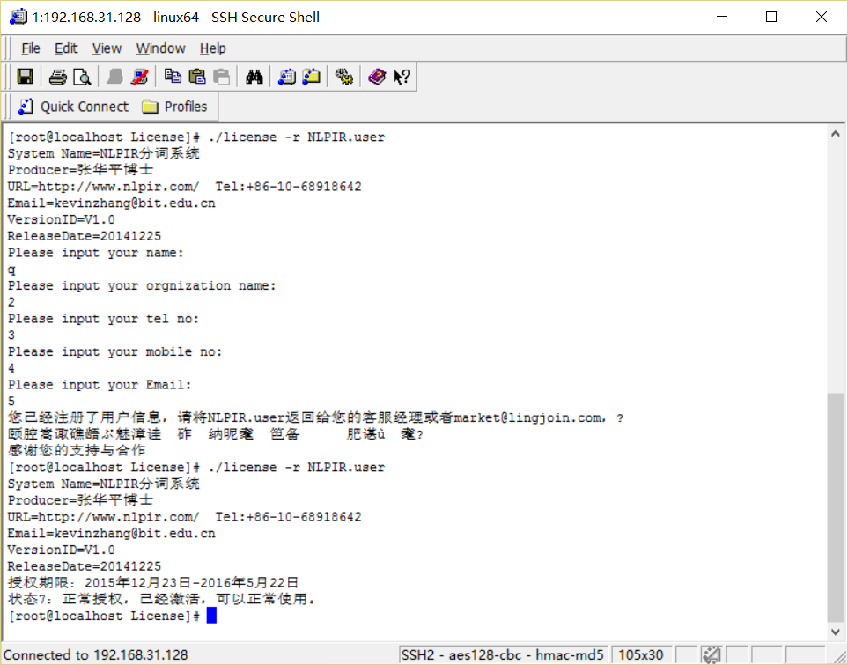

## Step 3b. Register License File in Windows ,Skip to Step 3a if Linux OS (Windows下注册授权文件；如果是Linux操作系统，跳转到Step 3a)

1)Run License09Soft.exe；

2)Select license file （选择授权文件）；

3) Check the license status and judge if the file is valid (查询状态即可判别授权是否有效）；

3). Register your information according to the instructions. And send the modified license file to your service agent.

（填报相关数据信息后，将此时修订后的授权文件发送到直接联系的客户经理，即可获取商用授权。）

Illustration as follows (示例如下图):

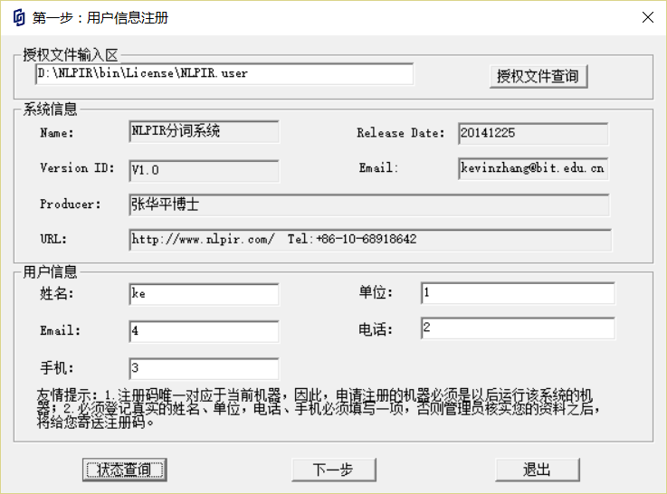

## Step 4. Replace the system license file with the license file returned from the service agent. （将从经销商手中获取的授权授权文件替换到系统指定的文件夹中）

## FAQ

## Q1: Why the licensed file cannot work? (为什么授权文件不起作用)

1) The license program and license file must be run in the given machine. The licensed file can not apply in another machine. (授权程序与授权文件必须在指定的机器上运行，授权的文件不能应用于其他机器上)

2) The working machine should be same with licensed one. (工作机器必须与授权机器一样)

# Contacts



张华平 博士 副教授 研究生导师

北理工大数据搜索挖掘实验室 主任

地址：北京海淀区中关村南大街5号 100081

电话：+86-10-68918642 13681251543(助手电话)

Email:kevinzhang@bit.edu.cn

MSN: pipy_zhang@msn.com;

网站: http://www.nlpir.org (自然语言处理与信息检索共享平台)

http://www.bigdataBBS.com (大数据论坛)

博客:http://hi.baidu.com/drkevinzhang/

微博:http://www.weibo.com/drkevinzhang/

Dr. Kevin Zhang (张华平，Zhang Hua-Ping)

Associate Professor, Graduate Supervisor

Director, Big Data Search and Mining Lab.

Beijing Institute of Technology

Add: No.5, South St.,Zhongguancun,Haidian District,Beijing,P.R.C PC:100081

Tel: +86-10-68918642 13681251543(Assit话)

Email:kevinzhang@bit.edu.cn

MSN: pipy_zhang@msn.com;

Website: http://www.nlpir.org (Natural Language Processing and

Information Retrieval Sharing Platform)

http://www.bigdataBBS.com (Big Data Forum)

Blog:http://hi.baidu.com/drkevinzhang/

Twitter: http://www.weibo.com/drkevinzhang/

